

www.allencountypublichealth.org

Summer 2016 Newsletter
Summer is Mosquito Season

The Allen County Public Health is planning to resume mosquito surveillance this summer. Mosquito traps will be placed at different locations in the county. Residents are encouraged to report large populations of mosquitoes and known man-made locations where mosquito breeding is likely to be taking place. Based on citizen reports, mosquito traps will be located in secure areas and mosquitoes will be collected for testing and identification as part of Ohio’s response to the Zika Virus outbreak.
Zika Virus has been a concern for us all since it first appeared in the Western Hemisphere in Brazil in May of 2015. Since then, cases of Zika virus infection have grown throughout Central America and are being seen in the continental United States. While mosquitoes spread many diseases, Zika virus poses a new risk to us because of its association with birth defects and the fact that infection can be spread by sexual transmission. The primary vector of Zika virus is the mosquito Aedes aegypti. These are tropical mosquitoes which would not likely survive Ohio winters. However, Aedes albopictus is a very similar type of mosquito found in Ohio which could potentially transmit Zika virus. Because of this possibility, the Ohio Departments of Health and Agriculture together with the Ohio Environmental Protection Agency and others are gearing up to coordinate efforts to monitor illness and mosquito populations to protect Ohioans from this and other deadly mosquito-borne diseases. As of April 25, there have been 12 cases of Zika virus infection reported in travelers returning to Ohio.
In Allen County, enforcement efforts to reduce mosquito breeding at sites will be taken if warranted to help protect us all. Below are the recommendations for protecting yourself and family from biting mosquitoes and how to reduce their breeding sites.
Public Health
Statistics
(January 1 - March 31, 2016)

- Immunizations given: 1,451
- Tuberculosis Tests given: 189
- Reportable Communicable
Diseases: total 329
0 cases of Class A Diseases
Diseases of major public health concern needing immediate response, e.g. human rabies, meningococcal disease.
321 cases of Class B Diseases
Diseases of public health concern needing timely response to pre-vent spread, e.g. E .coli 0157:H7, West Nile Virus, and TB.
8 cases of Class C Diseases –
outbreaks only
Outbreaks tracked whether the cause is foodborne, community, water-borne or zoonotic, e.g. norovirus, ringworm and MRSA.

- HIV Tests given: 358

- Number of births filed: 506

- Number of deaths filed: 365
- Environmental Division Field
Inspections: 1,416

Health Services Provided
- Women’s Preventive Health
Project caseload: 179
- BCMH Caseload: 440

- Caring For Two Home Visits: 293

- Family Planning Program
Visits: 343
- WIC Supplemental Nutrition
Program monthly average
caseload: 2,902

Protect Yourself - Mosquito Control & Bite Prevention

Use insect repellent: When used as directed, insect repellent with DEET is the BEST way to protect yourself from mosquito bites. Environmental Protection Agency (EPA)-registered insect repellents are safe for even children and pregnant women. Products containing DEET include Cutter, OFF! and Skintastic.

Treat clothing and gear: Wear pants and long-sleeved shirts. For extra protection treat clothing and tents with permethrin or purchase permethrin-treated clothing and gear.

Mosquito-proof your home: Take steps to avoid mosquitoes entering your home:

Use screens on windows and doors. Repair holes in screens to keep mosquitoes outside. Use air conditioning when available.

Keep mosquitoes from laying eggs in and near standing water around your home. Once a week, empty, turn over, cover, or throw out items that hold water, such as tires, buckets, planters, toys, pools, birdbaths, flowerpots, or trash containers both inside and outside your home.
-CDC, August 2015

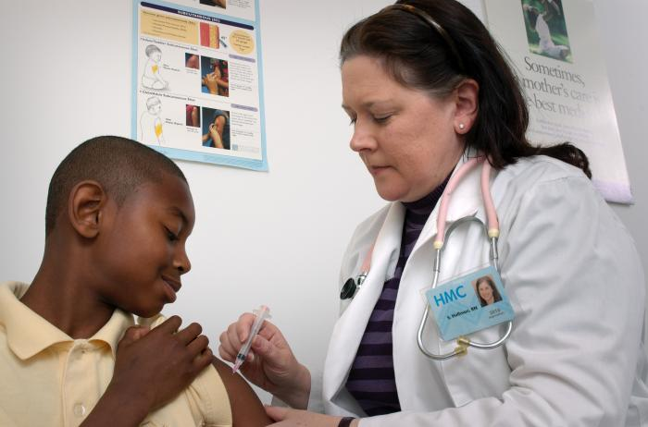 -Public Health Images Library, CDC
ACPH Partnership to Save Lives

Allen County Public Health is partnering with Coleman Professional Services and the Mental Health Recovery Services Board to equip law enforcement officials with the Project DAWN Kits. Project DAWN Kits (Death Avoidance With Naloxone) have the potential to rapidly reverse the effects of an opioid overdose.

Money for naloxone kits for first responders was allocated to the Ohio Department of Mental Health and Addiction Services (OHMAS) from the state budget for naloxone distribution by local health departments. Allen County Public Health distributed 53 kits to various county law enforcement agencies on May 18, 2016. Although the drug that is in the kits, Naloxone, is available to the public through other means, Project DAWN Kits ordered by Allen County Public Health can only be given to law enforcement. It is expected that more funds will be available for additional kits in the future.

While the first priority in using a Project DAWN Kit is to save a life from an opioid death, the partnership with Coleman Professional Services allows for individuals who have been treated with the kit to be referred to services that can assist them after their overdose. After a police officer uses a Project DAWN Kit, that officer will forward information to Coleman’s We Care hotline. The information will allow the kits to be tracked, but will more importantly provide an opportunity to connect the overdose victim to treatment services.

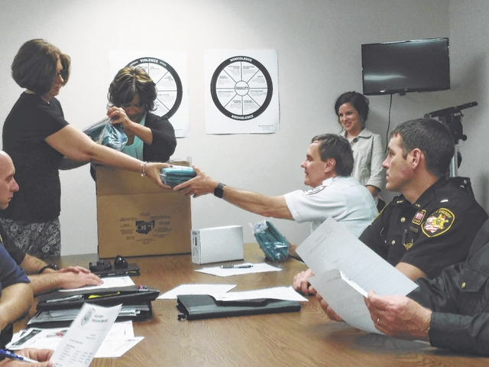
-Photo by Craig Kelly
The Lima News, May 19, 2016

Deb Roberts and Tami Gough of Allen County Public Health distribute Project DAWN kits to Shawnee Township Police Chief Michael Keith.

New Immunization Requirements for Teens Entering 7th & 12th Grades

Allen County Public Health (ACPH) is ready to help students meet the new state requirement for the meningococcal vaccine. In an effort to boost protection from meningococcal diseases caused by Neisseria meningitides, or meningococcus bacteria, the vaccine is now required for students entering the 7th grade, with a second dose requirement prior to entering 12th grade. Two doses for seniors will not be required if the first dose was received after age 16 or if the child is a senior and is age 15. Students without proof of vaccination can be subject to exclusion from school.

We will be hosting a special clinic for students needing the meningitis vaccine on August 31, 2016 from 2:00 – 5:00 p.m. Our regular weekly immunization clinics are available on Wednesdays and Thursdays by appointment only. Call or visit our website to schedule an appointment. Costs for immunizations will vary depending upon eligibility requirements, and we do have vaccine available for those children who are covered by private insurance. Please call the Nursing Division at 419-228-4457 for details.

Adolescents and young adults aged 16-23-years-old are more at risk for meningococcus bacteria. Illness is often severe, and death can occur in as little as a few hours. The vaccine offers excellent protection.

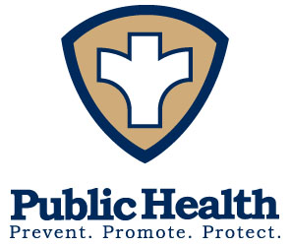
219 E. Market Street, P.O. Box 1503, Lima, Ohio 45802-1503 | Phone: 419-228-4457 | Fax: 419-224-4161

An Equal Opportunity Employer and Provider of Services Serving All Allen County Including the Cities of Lima & Delphos

